Cambok!
by Sir Dafydd ap Gwystl

When reading a. book recently I came upon a manuscript illustration that caught my interest (below). It showed a bunch of young men from the middle fifteenth century playing a game with some type of heavy hockey sticks and an inflated ball.¹ The illustration had no description of the game, and no name for it, but I resolved to discover what the game was, to make sticks and a ball, and to play

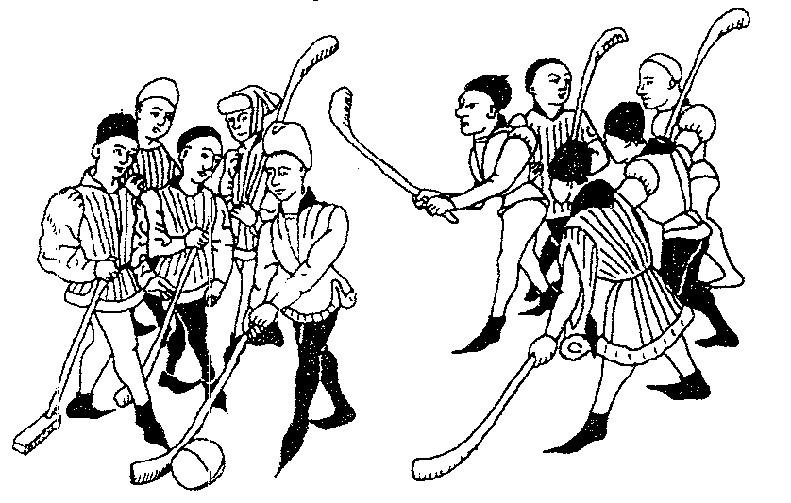

This article is the product of that research. The, manuscript illustration provides some solid information about the game. Comparison with the size of the figures in the illustration shows the approximate dimensions of the ball and the sticks, and the shape of the sticks. The seams on the ball are visible, so the ball can be reconstructed with some accuracy. It is clearly a team sport, as there are nearly a dozen players visible in the manuscript illustration, and they seem to be clearly divided into two teams. One of the sticks is made differently from the others. Finally, by the clothing worn by the players, this is a sport that would be familiar to the nobility and the gentry, not just the common folk.

Of course there is also quite a bit that we do NOT know about the game. What was it called? What were the rules? How many players were there? Was there a goal, or a goal line, or what? Due to the lack of concrete information it isn't possible to answer any of these questions with certainty.

The name of the game illustrated is unlikely ever to be discovered. Note that the names of games would often change from one parish or county to another.² Cambok was one of the games forbidden in a 1363 edict (along with handball, football, and stickball). It was played with a stick, and the name Cambok comes from the name for the bent stick carried by shepherds. Goff and Bandy may have been other names for games played with bent sticks.³ Other names for active games with bent sticks were Creag among the Celts in Ireland and La Crosse in France, both of these names coming from the shape of the stick: bent like a bishop's crozier.⁴ Hockey (in England), Hurling (Ireland), and Shinty (Scotland) are all names for similar games played with bent sticks.⁵ As the manuscript illustration is French, it might be that the players would have called the game La Crosse, but I did not want to use that name because of its modern connotations, so I decided to call the game Cambok.

The Ball

Alexander Barclay (1508) mentions that balls were, made with the bladders of pigs when they were slaughtered. The bladders were blown up with air and beans and peas put in to rattle around inside, and games were played with them that involved striking with the hands and feet.⁶ This construction is almost certainly that of the Cambok ball. Other games with sticks referenced have small hard balls, but the large size of the ball in the manuscript illustration makes it most likely that an inflated ball of the type described by Barclay was used, rather than a solid or heavily packed ball.

A seam is clearly visible in the manuscript illustration, and runs straight across the ball. A tennis ball of the 16th century found in the roof beams of Westminster Hall has similar seams,⁷ so it is very likely that the Cambok ball was made with a leather cover of the same design. The pattern is quite simple: four pieces of leather are sewn together to mark the ball with seams running from one pole to the other, sort of an "orange quarter" construction. Modern footballs and rugby balls are made in a similar fashion. If the leather pieces are the right shape the resulting ball can be spherical, like the Cambok ball or the Westminster tennis ball.

I did not have a pig's bladder convenient when I made the ball, so I took a cheap commercial inflatable ball and put that inside the leather skin, and it worked admirably.

The Cambok Sticks

The sticks used in the manuscript illustration are very similar in the length of their shafts (4' to 5') and in the angle of the head (around 45º) to modern hockey sticks. The heads are much heavier than modem hockey sticks. It is likely that most of the medieval sticks shown in the manuscript illustration were constructed of a single piece of hardwood. One of the sticks in the illustration is very different from the others, however. Instead of being made of a single piece it is of two pieces, a simple block for a head and a straight shaft set in at an angle. Although it is impossible to know for sure, it is possible that this stick was made deliberately for the game rather than being a shepherd's crook used for another purpose.

Not having a stand of hardwood around to massacre for Cambok, I made my first set of sticks by laminating spruce 2x4s together, cutting the shape roughly on a bandsaw, and sanding down to the final shape of the head. The shafts I made with any scrap wood I had around (mostly rattan that wasn't good enough for swords). Of the nine sticks I originally manufactured, three broke in the first 15 minutes of play and the rest lasted for the three hours or more that we played. Although sticks made to this design are probably durable enough, especially if better wood is used for the shafts, it is very time-consuming to fit the mortises and tenons together tightly, and the resulting joint is not very strong. In the, future I intend to try and make sticks more quickly by laminating sections of Birch plywood together to make a one piece shaft and head. This should be a stronger stick, and also faster to make.

Medieval Rules to Ball Games

Game rules are very rarely described in period, and physical games even less commonly than those of cards, dice, or other pursuits. Since it is not possible to find exact rules for the game played in the picture, the next best thing is to discover rules to similar games and make up rules for Cambok using them as a guide. My sources refer mostly to the United Kingdom; France's games are likely to be similar, but I would hesitate to generalize further than that.

Ball games were very common in the Middle Ages and Renaissance. They were very popular, and often very brutal. Tomas Elyot, writing in The Book named the Governor (1531) says that they. are "nothing but beastly fury and extreme violence".⁸ A wide variety of ball games were played. They seem to have had few rules, and any number of players on a side. The field of play might be a single field or common, or even an entire parish. For some rugby-like games the objective was simply to carry the ball past a goal line; for others the goal might be a house. In all of these games there were two distinct teams, each trying to get the ball to their enemies' goal and defend their own.⁹

Cambok is likely to have been a game where there was a distinguished goal. This could have been the wall of a house, an area of ground, or just about anything. Some ball games (without sticks) would have very large objectives very far apart (miles, often); the game would involve the attempt to score a single goal, and would often take the whole day. This might be a realistic version of Cambok, but it also is very hard to re-create at any event smaller than Pennsic. The other possibility is a smaller field and smaller goals, and this is much easier to run at an event.

Medieval rules would probably have been very simple - no hitting your opponent with your stick. Even this is conjecture, but a sensible one - it only takes one or two blows with a heavy five-foot long stick to incapacitate an unarmored opponent. Since Cambok games were not battles where large numbers of players were killed or crippled, they probably didn't hit each other with the sticks. With fists, elbows, feet, and anything else, yes, but not with sticks.

Them was almost certainly no 'goalie' - no player with special rules. Similarly, there would be no 'out-of-bounds', no substitutions, no time-out. These are all modern frippery. It is possible that them would be rules against certain types of contact with the ball. For example, in modern Soccer the hands and arms cannot be used, and in Ice Hockey the puck can be kicked (but not into the goal) and grabbed (but only if dropped immediately). Similar rules existed in some (but not all) medieval ball games. Since I had relatively few sticks I decided that any contact with the ball was legal for Cambok, as this would allow many more people to play than just the few sticks I had.

Cambok in the Current Middle Ages

Physical games in the Middle Ages and Renaissance were much rougher than those with which we are familiar. Deaths and severe injuries were not uncommon. King James I of England in his Basilicon Doron (1599) forbids his son to play football as 'meeter for laming than making able the users thereof."¹⁰ The broken limbs and injuries strike me as part of the recreation of the period that is better avoided, so I have added some additional rules to SCA Cambok that are not likely to have been in the period form.

Medieval Cambok probably had few, if any, rules. Striking another player was probably a normal part of play. I wanted a game that was close to the medieval form, but without much of the potential for injury. Striking another player with intent to harm was right out. In Medieval Cambok you would likely have been able to hit another player with your fists, tackle him, or do anything else you wanted. In SCA Cambok you can push and shove, but not grab (which causes falling and wrestling) or strike. Blocking with the body is fine. Other than that modification there were only two rules I felt it necessary to introduce to make the game safe enough for SCA play.

The sticks are the most dangerous implements on the field, so introducing a rule against "High Sticking" is a good idea. Sticks cannot be carried, waved, or swung above the waist. Since balls that are up in the air can be batted with the hands, head, or whatever, I don't feel that this makes a large change upon the play, and it makes it much safer to be out there playing.

The last rule I thought necessary was to disallow carrying the ball. Some medieval games did not allow holding or carrying the ball, so this is not a modern rule, but I have no information on whether that would be the case with Cambok. Carrying the ball introduces the necessity for tackling the ball carrier, and that causes injuries.

Notes
1 Collins, Marie, and Davis, Virginia, A Medieval Book of Seasons, (New York: Harper Collins, 1992), p 117. The illustration is from the Hours of the Duchess of Bourgogne, around 1450. The original is in the Musée Condé, Chantilly.

2 Stone, Lilly C., English Sports and Recreations, (Folger Shakespeare Library: 1960; 1979), p 8.

3 McLean, Will, and Singman, Jeffrey L., eds, The Chaucerian Handbook; A Manual for Living History c1342-1400, (Vox Clamantis Monographs I, 1993), p 116-117.

4 Salamallah the Corpulent, Medieval Games, (Albuquerque: Raymond's Quiet Press, 1982), p 103.

5 Strutt, Joseph, The Sports and Pastimes of the People of England, (New York: Augustus Kelley, 1970). Originally published 1801; modified and enlarged by J. Charles Cox. p 92. Another game also called Hurling was similar to rugby, and seems to date back to Roman times, but was not played with a stick.

6 Strutt, p 94.

7 Starkey, David, ed. Henry VIII; A European Court in England, (London: Collins & Brown, 1991), p 170, illustration XI.49. The tennis ball illustrated is made of dog leather with a core of packed hair.

8 Stone, p 9.

9 Stone, p 8-9.

10 Stone, p 9.

