More Period Card Games
by Master Dafydd ap Gwystl

This is a continuation of my article on period card games from the previous Oak (issue #5). For an overview of card games in period, please refer to my earlier article. Here I describe the rules to three more card games: Putt, Karnöffel, and Reversis. Putt is a late Elizabethan and Jacobean game favored by card sharks, cheats, and gamblers. Karnöffel is the oldest card game for which we have rules, dating back to 1426. Reversis is late 16th century. Enjoy!

Sources
Cotton, Charles, The Compleat Gamester. London: 1674)
Parlett, David, The Oxford Guide to Card Games, (Oxford and New York: Oxford University Press, 1990)
Dummett, Michael, The Game of Tarot, (London: Duckworth, 1980)

Putt

Putt uses the 'standard' deck: 52 cards, French suit system. Putt is played by two or three players. It is described by Cotton as the favorite game of cheats and card sharks, and he goes into great detail on how they go about cheating. I have not been able to date Putt any earlier than Cotton (yet). Games related to Putt appear in the late 16th century in France.

Cards in Putt are ranked as follows: (high) 3, 2, A, K, Q, J, 10, 9, 8, 7, 6, 5, 4 (low)

A card is cut for each player, and the highest card (by the order above) shuffles and deals. Each player is dealt one card at a time until everyone has three cards.

Putt is a vying game. Each player antes before the deal. After the deal the eldest hand may choose to bet ("putt") or not. If he Putts and his opponent(s) do not see him (match his bet) then he wins the pot. If one (or both) opponents see the bet then the hand is played out, and the winner is the one that takes at least two tricks. The eldest hand always leads to the first trick, and the winner of each trick leads the next one. If a trick is tied then lead remains the same on the next one.

Cards count only for their ranking--suits are ignored. There is no trump, and players need not follow suit. Players may play any of their cards each trick, and the highest card played (according to the ranking given above) wins. If two or more cards tie as the highest cards in the trick then nobody wins that trick. If nobody wins two or more tricks then the money in the pot remains to the next hand.

Karnöffel

Karnöffel is the oldest documented card game, with its first reference in Nordlingen in 1426. References to it are common in 15th and 16th century Germany, and it survives (under the name Kaiserspiel) to the present day in Switzerland. Karnöffel is properly played with a 48 card German suited deck (no aces). The German decks have Obers and Unters as court cards instead of Queens and Jacks (Ober= =Over; Unter= =Under). The names refer to the position of the suit sign on the card. If playing with a French suited deck, use the Queen as equivalent to the Ober in each suit and the Jack as equivalent to the Unter.

The game is for four players. Opposite players are partners. Five cards are dealt to each player and each side's objective is to win the most tricks. Each player's first card is dealt face up, and the lowest ranking of them (using the normal ranking: K 0 U 10 9 8 7 6 5 4 3 2) establishes a quasi-trump suit. If there, are ties, use the suit dealt first for trump. Some of the cards in this "trump" suit are trumps (and so beat some or all cards in a non-trump suit if played), and others are not trumps.

Players need not follow suit, and partners may discuss between them what card to play. Play continues until either side has taken three tricks. A trick is taken by the highest card in the suit led, or by the highest trump if any are played. Note that not all cards of the quasi-trump suit are trump cards. In plain suits the order is the normal one: King, Ober, Unter, 10, 9, 8, 7, 6, 5, 4, 3, 2. In the quasi-trump suit, the following cards are trumps:

Card Name
Unter Karnöffel beats any other cards (as it is the highest trump)
Seven the Devil beats any cards except the Karnöffel, but only if led
Six the Pope beats all plain suit cards
Two the Kaiser beats all plain suit cards
Three the Overtaker beats all plain suit cards except Kings
Four the Untertaker beats all plain suit cards except Kings and Obers
Five the Suit-taker beats all plain suit cards except face cards

The other cards in the quasi-trump suit (that is, the K, 0, 10, 9, 8) are not trump--they act as a normal suit. The Devil (Teufel) beats all other cards (except the Karnöffel) only if it is the first card led to a trick, and it may not be led to the first trick. It will not beat any card in any other circumstance. The remaining cards in the quasi-trump suits count as a. plain suit. This gives the following order in the "trump" suit:

U, (7), 6, 2, K, 3, 0, 4, 5, 10, 9, 8, (7)

This strange looking order follows logically from the rules for the true trump cards. The seven of trump is second highest if led, and lowest otherwise.

Reversis

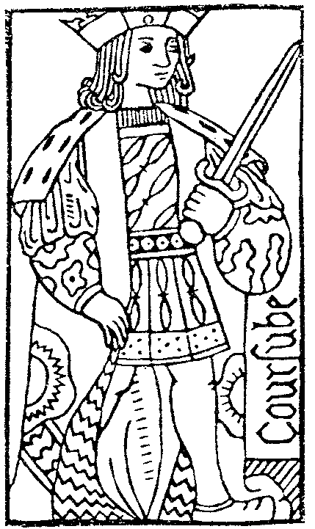
Reversis is first documented in 1601. It is a trick-avoiding game where each player attempts to avoid taking tricks with certain cards in them (similar to Hearts). Several games of the trick-avoiding type seem to have existed in the 16th century, but no rules survive and they cannot be conclusively connected to Reversis (or any other surviving game). The rules given here are as described by Parlett.

The game is played with the familiar 'standard' deck: 52 cards, French suit system. There arc four independent players (no partners). Each player is dealt 12 cards, and may discard one before play begins. Players must follow suit if possible. There is no trump. Court cards (and the aces) count against a player. The winner is the one to take the fewest such points.

Card Point Values:
Ace 4
King 3
Queen 2
Jack 1
All others -

Each losing player must pay the winner according to the number of points taken. I suggest that each loser pay a standard stake (for example, 2 denari) to every other player that took fewer points than they did. For a (very) high-stakes game, have each loser pay the difference between the number of points they took and the number each opponent took to that opponent.

