A Simple Gothic Bench
By Master Dafydd Ap Gwystl (David Kuijt)

In the last five years splendid medieval pavilions have replaced blue plastic tarps at tourneys and camping events. The use of medieval furniture, however, has lagged somewhat behind this trend. Although a few craftsmen are making fine medieval and Renaissance furniture, most of us still sit on director's chairs at events. This article is aimed at making some medieval seating more accessible.

Medieval furniture can demand a lot of skill and workmanship. Some medieval furniture does not work well in a Society environment, where we must pack all our goods in our cars before and after an event. There is no reason to resign ourselves to director's chairs, however, as some medieval seating was quite simple and can be easily made by anyone who can use a drill and a saw.

This article describes how to build a simple Gothic-style bench. The materials are very inexpensive - around ten dollars or so. The skills needed to make this bench are not very demanding, as the design is quite simple and does not require much experience with woodworking. Complex tools are not needed. The bench that results can be packed as a relatively flat set of boards. Best of all, the result is both attractive and medieval.

Brief Notes on History

The bench described here is a simple slab-ended stool with a decorative underframe.¹ Both vertical and angled supports (legs) existed in period, although the vertical supports seem to be more common. Examples of this design of backless stool appear throughout the fifteenth and sixteenth century in paintings and manuscript illustrations. I do not know of any examples of this style of bench dating from earlier than the fourteenth century, because manuscript illustrations are generally of little use before the rise of realistic portrayals of mundane objects in the fifteenth century, and surviving examples of actual furniture from before 1400 are rare. Clear examples of this type of bench appear throughout the fifteenth and sixteenth centuries in western Europe. Penelope Eames mentions slab-ended stools in the Bayeux tapestry,² but all the furniture there is shown full-front and stylized, so her interpretation is uncertain.

The stool design is very simple, and is closely related to that of the slab-ended or six-board chest. Slab-ended chests were common throughout the Middle Ages, and examples survive from the tenth century until the seventeenth.³ Note that slab-ended chests would also serve as seating, so it seems reasonable to suppose the existence of slab-ended stools from the tenth century on.

Construction

In the directions that follow I leave it up to you whether to use screws or wooden dowels to fasten the bench scat to the rails. Screws are modern, and would not have been used; they are also much better fasteners and are easier to use effectively.

If you decide to use screws, 2" drywall screws work well on pine. Be sure to countersink the screws, and also make sure to pre-drill pilot holes for them or else the wood will split. After you have placed the screws, you should plug the countersunk screw holes with a wood dowel to hide the screw heads. Cut off the plug at the scat level using a wood chisel, and then sand the plug flush. A properly countersunk and plugged screw hole will look identical to a dowel.

If you decide to use dowels, 1/4" diameter hardwood dowels are best. 2" long will probably do the trick. Glue the hole carefully before inserting the dowel. As dowels are less sturdy than screws, you may want to use more than two to fasten each rail to the bottom of the bench seat (perhaps up to five per rail). Leave a little of the dowel standing up out of the hole so that you can cut it off at the seat level and sand it flush.

Even the dowel construction method is not necessarily the way these stools would have been built in period. Extant stools of this design are on display in the Cloisters (Figures 1, 2), but I have not yet been able to visit them to determine how the understructure is fastened to the bottom of the seat.
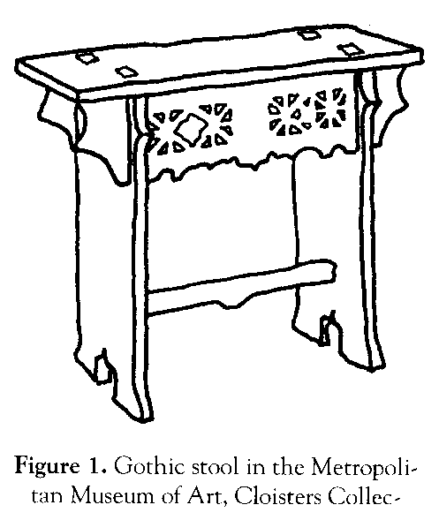
Further, there are many examples of benches where the top part of the leg pieces is extended in two tenons that pierce the bench seat (as seen in Figures 1, 2, 3 and 4) in two through-mortises.

This design is more stable than the one I describe, but requires four mortise-and-tenon joints. I encourage you to explore this technique, but I have deliberately avoided using it here to keep this bench design simple.

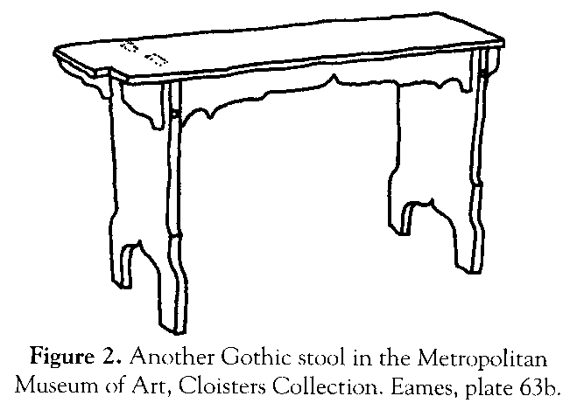

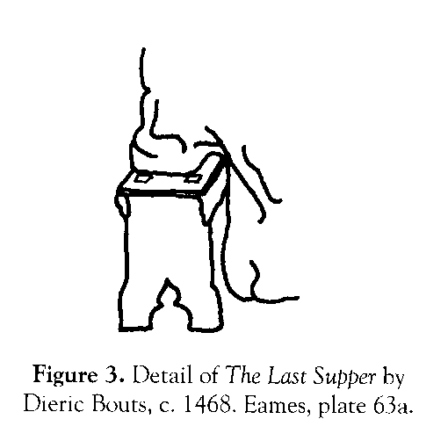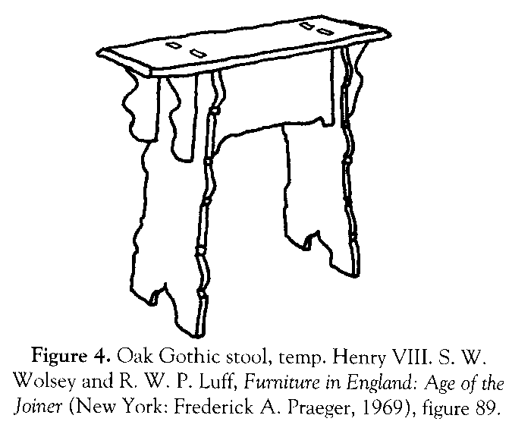

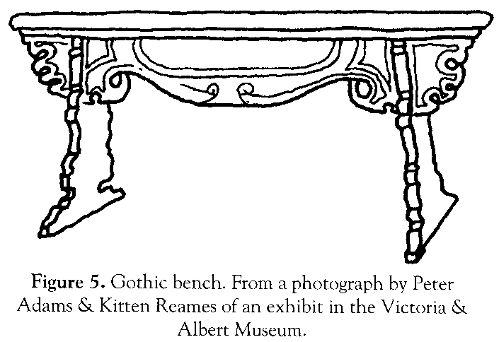

In this design the leg and the rails interlock with each other. This method is clearly used in all the extant benches examined (Figures 1, 2, 4, 5). In some benches in manuscript illustrations, the leg piece is lapped by the rail (Figures 3, 6, and 7) or the rail ends at the leg (Figures 9 and 1 0 - perhaps significantly, both of these benches also have an additional runner at the bottom of the legs for reinforcement).

Materials

6' long 1x12" board
6' long 1x4" board
wood glue
1/4" diameter dowels or 2" long drywall screws

The benches I've constructed from this pattern have been made in pine Knotty pine is very inexpensive - the two boards - needed for one bench cost me only ten dollars. In poplar the materials might cost around twenty dollars; oak, maple or nicer hardwoods would cost more (that amount of red oak would cost sixty dollars at my normal source). In harder woods the work will take slightly longer.
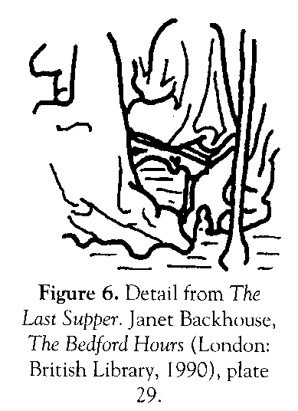

Any of the common woods for furniture could have been used for these benches. Oak was the favored wood for furniture in the Middle Ages and Renaissance. Poplar and pine were also commonly used, but almost any hardwood available would be a possibility. Elm, walnut and cypress are among examples of other woods used for medieval and Renaissance chests and chairs.⁴

Tools Needed
drill and drill bits
scroll saw (or jigsaw and crosscut saw)
sandpaper or files
3/4" wood chisel and mallet
a screwdriver and counter-sink bits (if you're using screws)
clamps

The tools above are minimal. You can make the whole bench without any power tools - a jigsaw for the decoration, a crosscut saw, a hand drill and a chisel. If you have access to power tools, they may speed your work. With a bandsaw and a planer it took me about two hours to finish a single bench. Doing the decorative cuts by hand and using a hand planer to finish the board edges will take longer, but a single bench should still be a half-day project.
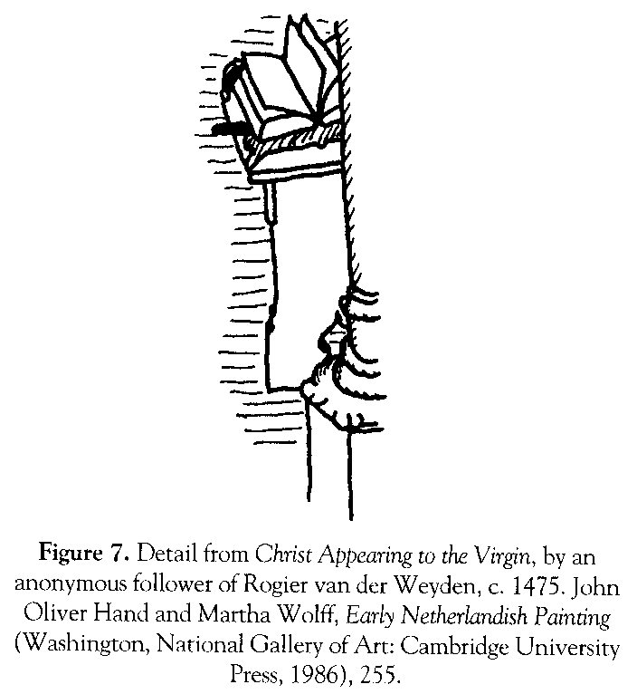

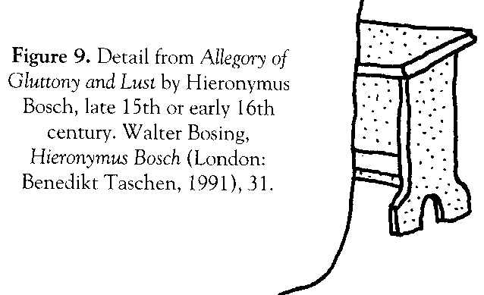
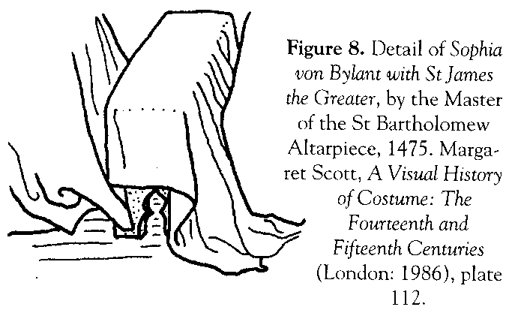

Decoration

A little decorative scrollwork will make the difference between a crude-looking bench and one that is really attractive. Visual sources and surviving benches show a variety of designs, from very simple (Figures 8 and 9) to extremely ornate (Figure 5). Pierced decorative designs were also used, as shown in Figures 1, 5 and 6.

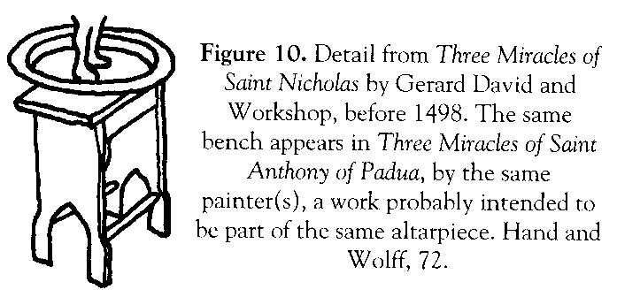

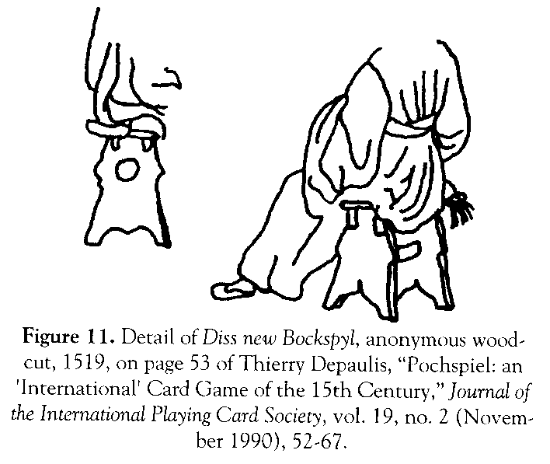

Some of the benches illustrated have a simple runner down near the base of the bench to further support the legs (Figures 1, 9, 1 1). One example shows a bench with two runners at the feet (Figure 10).

Instructions

1. Cut the 6' long lxl2" board into three pieces: one 36" long (for the seat of the bench) and two 16" long (for the legs). See Figure 12.
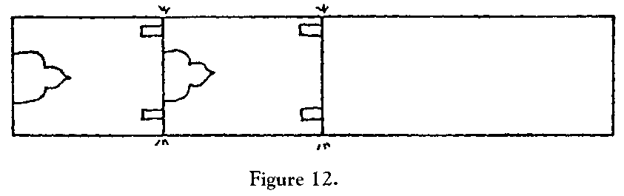

2. Cut the 6' long 1x4" board into two pieces, both 35" long. This will form the rails. See Figure 13.

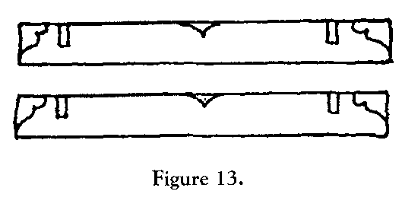
3. Pencil the decorative scrollwork patterns onto the rails and the legs. Also pencil the locking slots onto the top of the leg pieces and the bottom of the rails. The locking slots must be exactly 3/4" wide (the thickness of your boards). On the legs the locking slots are exactly 2" deep; on the rails they are exactly 1 1/2" deep. The decorative scrollwork dimensions are not crucial so I have left them out. Be creative. Thin pieces will be fragile, however - try to leave as much thickness on the rails near the locking slots as possible.

4. Using a jigsaw, scroll saw or band saw, cut along the pencilled lines for the decorative cuts and the vertical parts of the locking slots.

5. Using a 3/4" chisel, chop the waste out of the locking slots.

6. Check the locking slots for fit. File the slots until they fit closely. You should not need to force the legs and top together - eventually this will cause the wood to split and ruin your bench. If the legs fit too loosely your bench will wobble and will not be as sturdy.

7. Place the seat upside down on a flat surface. Put the rails and legs together and place the assembly on the bench, so you have the whole bench together (don't glue anything yet!) upside down. Carefully center the assembly on the bottom of the bench seat, then mark along the rails with a pencil between the legs of the bench.

8. Take the legs and rails off the seat. Drill four holes through the seat centered on the rails, about two inches from where the rails attach to the legs. See Figure 14.

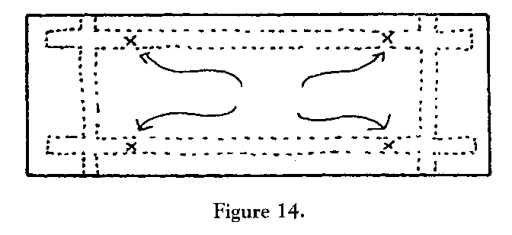
9. Put the leg and rail assembly together right-side-up on the floor (still unglued). Turn the seat over and reposition it on the rail/leg assembly (making sure the holes you have just drilled are directly over the rails), then drill into the rails using the holes in the bench as a guide for the drill.

10. Spread glue on the top of the rails (the part that touches the seat), then screw or dowel the rails to the bottom of the seat. Clamp the rails until the glue is dry. Cut off the protruding ends of the dowels with the wood chisel (or, if you used screws, countersink the screw heads and use a plug to hide the screw head, then cut off the protruding end of the plug). Clean up any visible glue waste. Note that you do not glue the legs to the rails - they simply slide in. This allows you to remove the legs to pack the bench flat in a car.

11. Finally, sand the surface of the bench, use files to clean up the decorative saw cuts if necessary, and finish the bench. A couple of layers of wax (butcher-block wax or bowling alley wax are best) is a good finish; modern finishes like polyurethane will also work. You can paint the bench if you wish.

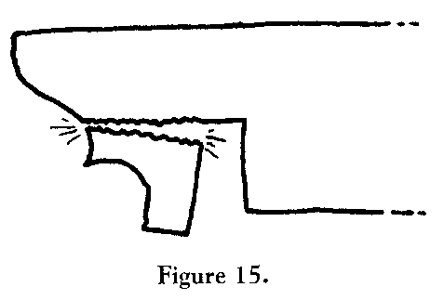
Postscript

The bench described above has a weakness. The carved scrollwork ends of the rails sometimes split off (see Figure 15). This happens to be a medieval problem also - some of the surviving benches show similar damage. There are two ways to avoid this problem.

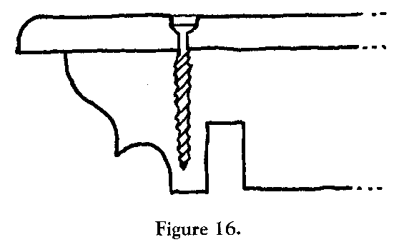

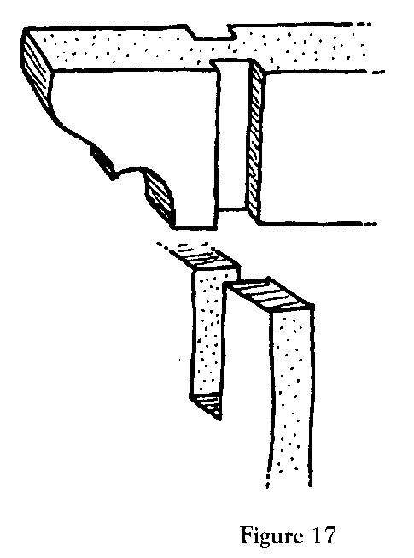
The first method is to put a screw or dowel through the end of the rail to reinforce it. Be careful not to let it poke out through the scrollwork, as shown in Figure 16.

The second technique was suggested by my friend Master Badouin MacKenzie. Instead of having the legs and rails have matching locking slots, make two shallow dados (3/4" wide, 1/8" deep, and all the way across the 3 1/2" width of the rail) in either side of the rail at each joint and a single locking slot 3 1/2" long and 1/2" wide in the legs for each joint. This will reinforce the rails. This technique requires more woodworking expertise and tools than the other method. The dados can be made by hand with a 3/4" chisel. If you have a table saw and dado blade, or a router table, you will be able to make the joints much faster. See Figure 17.

Notes
1. Penelope Eames, Furniture in England , France and the Netherlands from the Twelfth to the Fifteenth Century (London: Furniture History Society, 1977), 209. Figures 1 and 2 in this article show extant vertical-foot benches; Figures 4 and 5 show extant slanted-foot benches.
2. Eames, 206.
3. Eames, 138.
4. Eames, 135.

David Kuijt (2801 Ashmont Terrace, Silver Spring, MI 20906) is a graduate student working towards a Ph.D. in computer science at the University of Maryland. Dafydd ap Gwystl (Earl, Laurel, Knight, Sea Stag, Pearl, Golden Dolphin, Yew & Sinew, Fellow of the University of Atlantia) is an early fifteenth-century Welsh knight seeking glory, fame and fine clothing, fighting in France, Burgundy and Atlantia. He has more hats than any other noble in the kingdom of Atlantia.

